Infrared-Receiver

Introduction
An infrared-receiver is a component which receives infrared signals and can independently receive infrared ray and output signals compatible with TTL level. It's similar to a normal plastic-packaged transistor in size and suitable for all kinds of infrared remote control and infrared transmission.

Components
- 1 * KUMAN Uno board
- 1 * USB data cable
- 1 * Infrared-receiver module
- 1 * Remote controller
- 1 * 3-Pin anti-reverse cable

Experimental Principle
Control a certain key (for example, Power key) via a remote controller by programming. When you press the key, infrared rays will be emitted from the remote control and received by the infrared receiver, and the LED on the KUMAN Uno board will light up. Connect an LED to pin 13 on the KUMAN Uno board so that you can see remotely whether the Power key is pressed down.
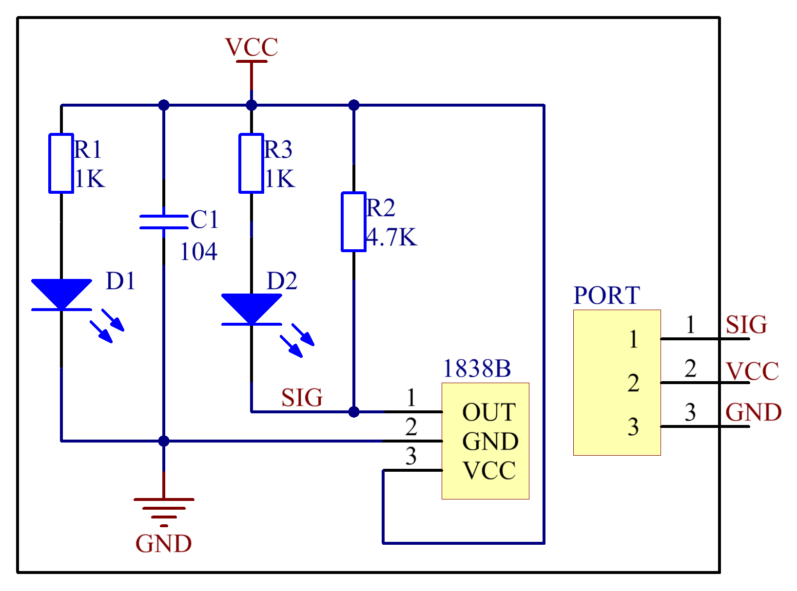

Experimental Procedures
Step 1: Build the circuit
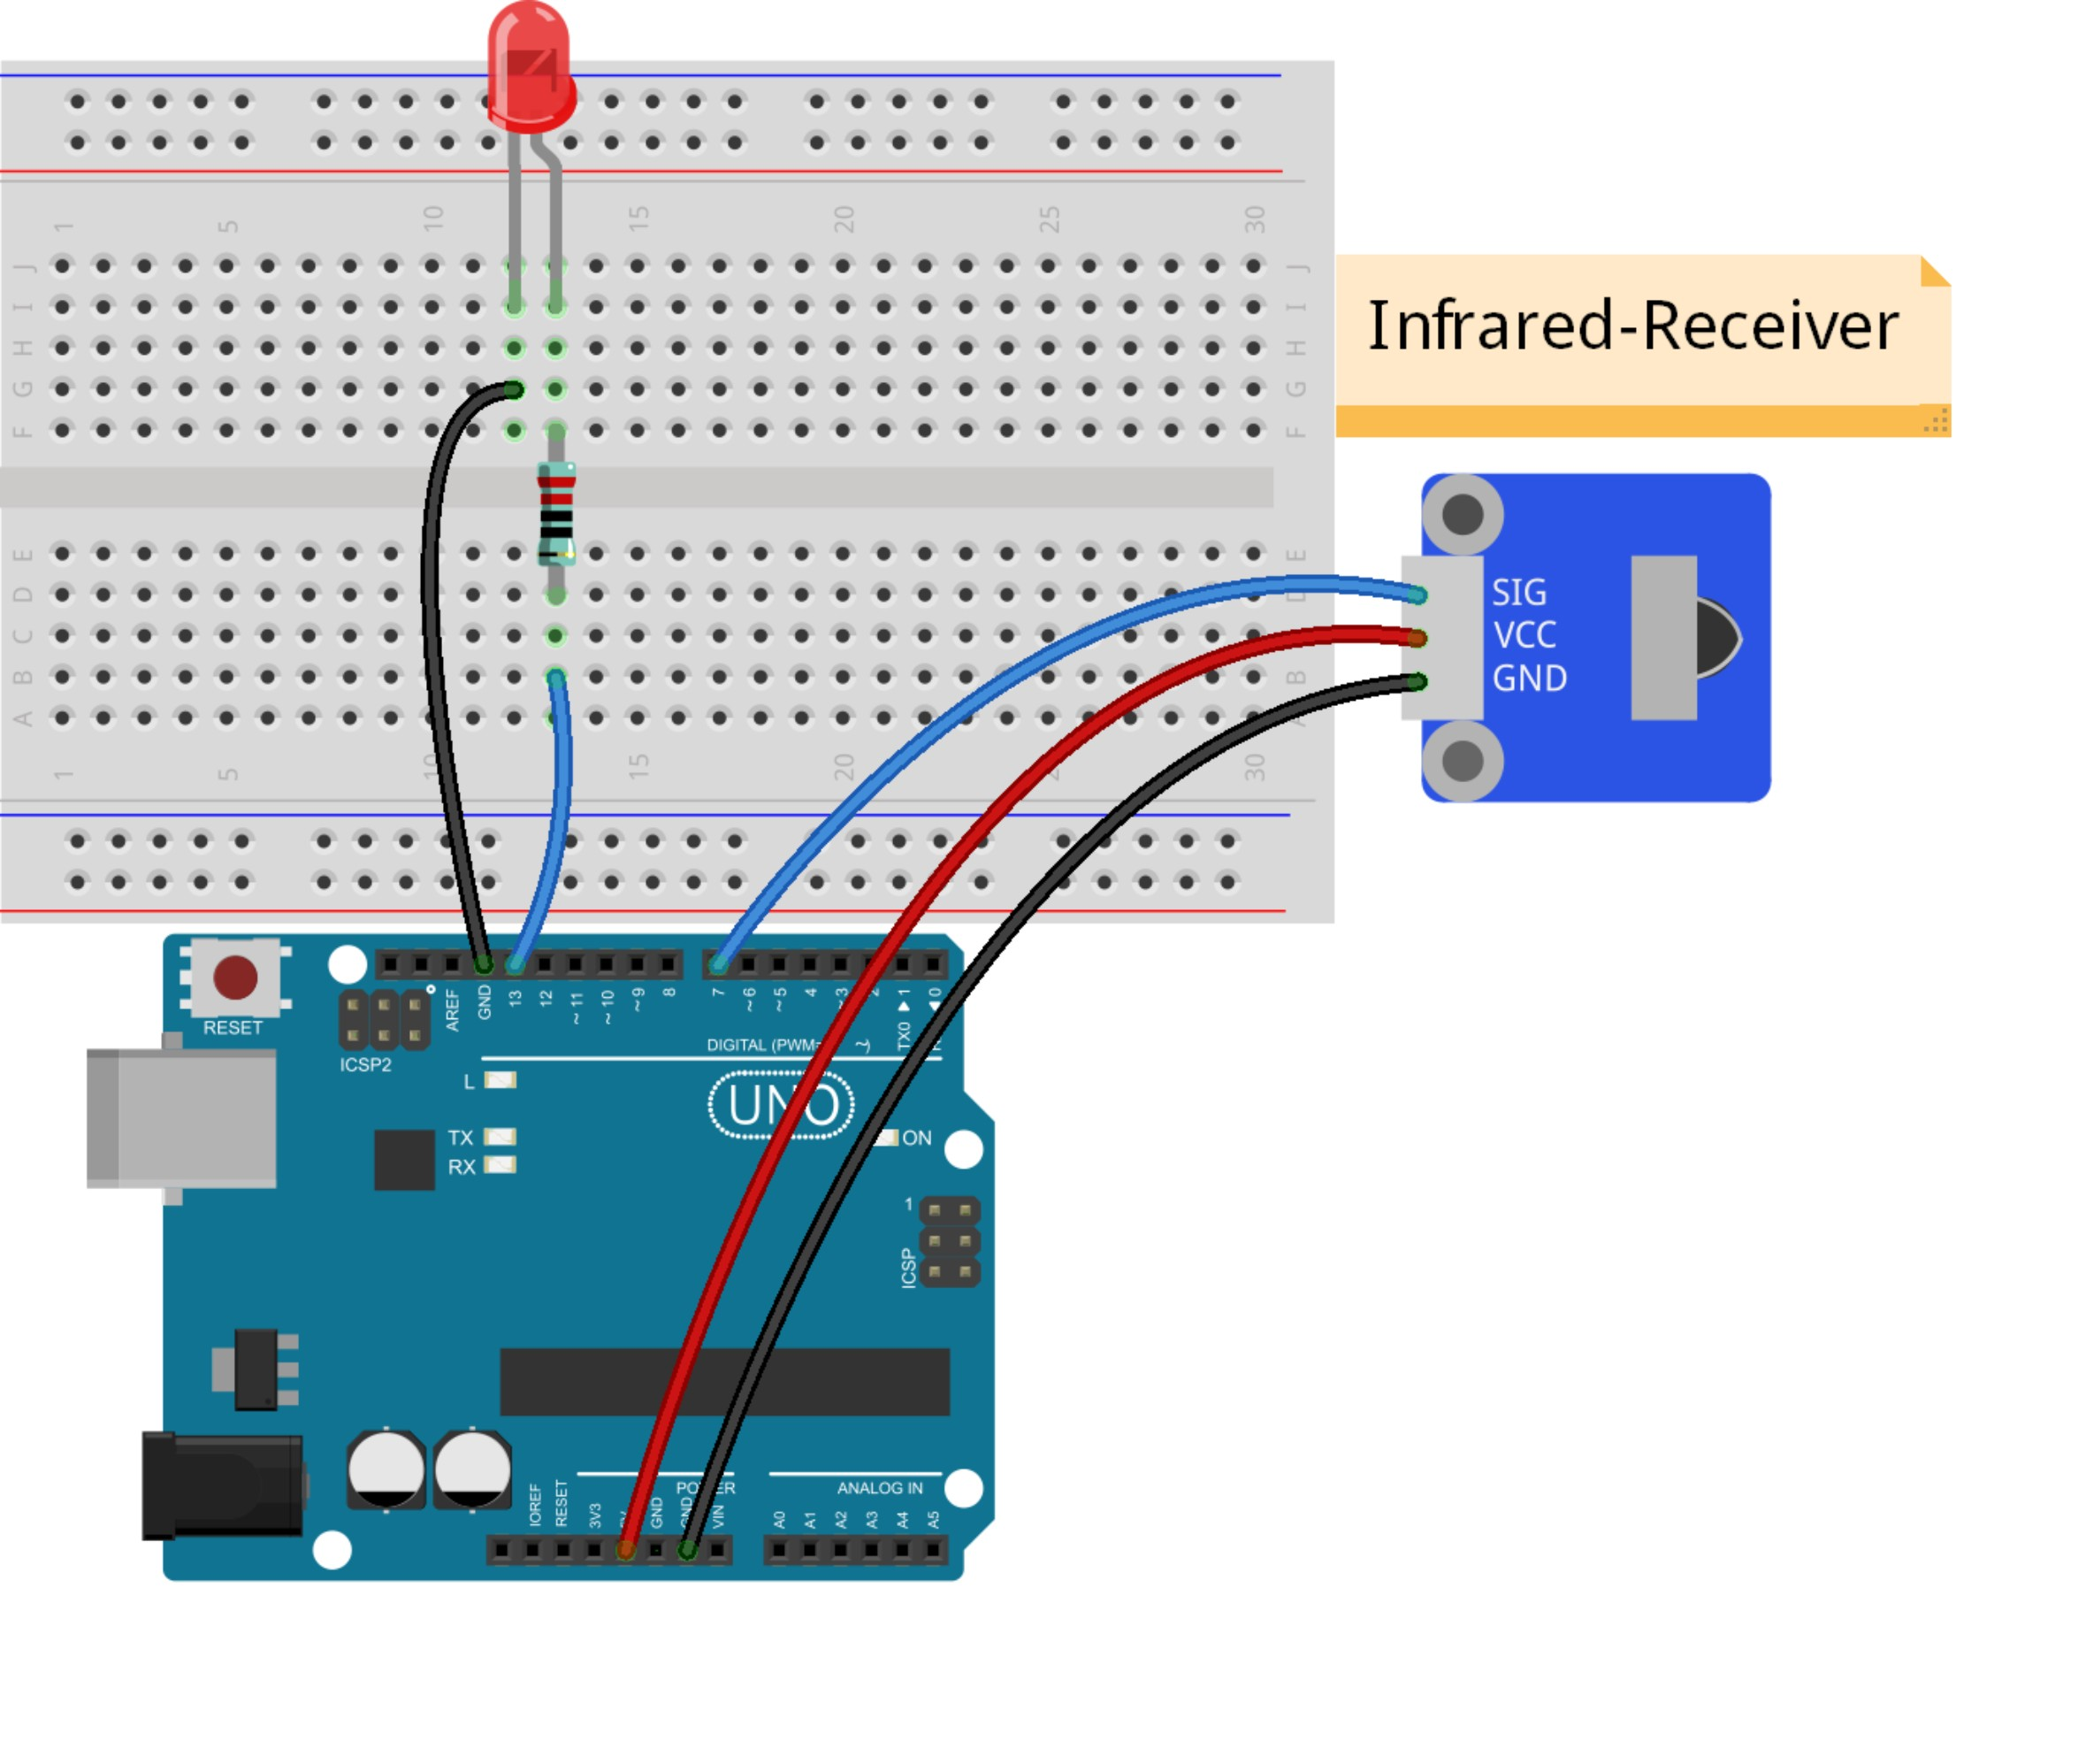

Note: Here you need to add a library. Refer to the description in LIBRARY
Step 2: Compile the code
Step 3: Upload the sketch to the KUMAN Uno board
Now, press the Power key of a remote control, and both the LED attached and that connected to pin 13 on the KUMAN Uno board will light up. Then press any key, the LEDs will light out.
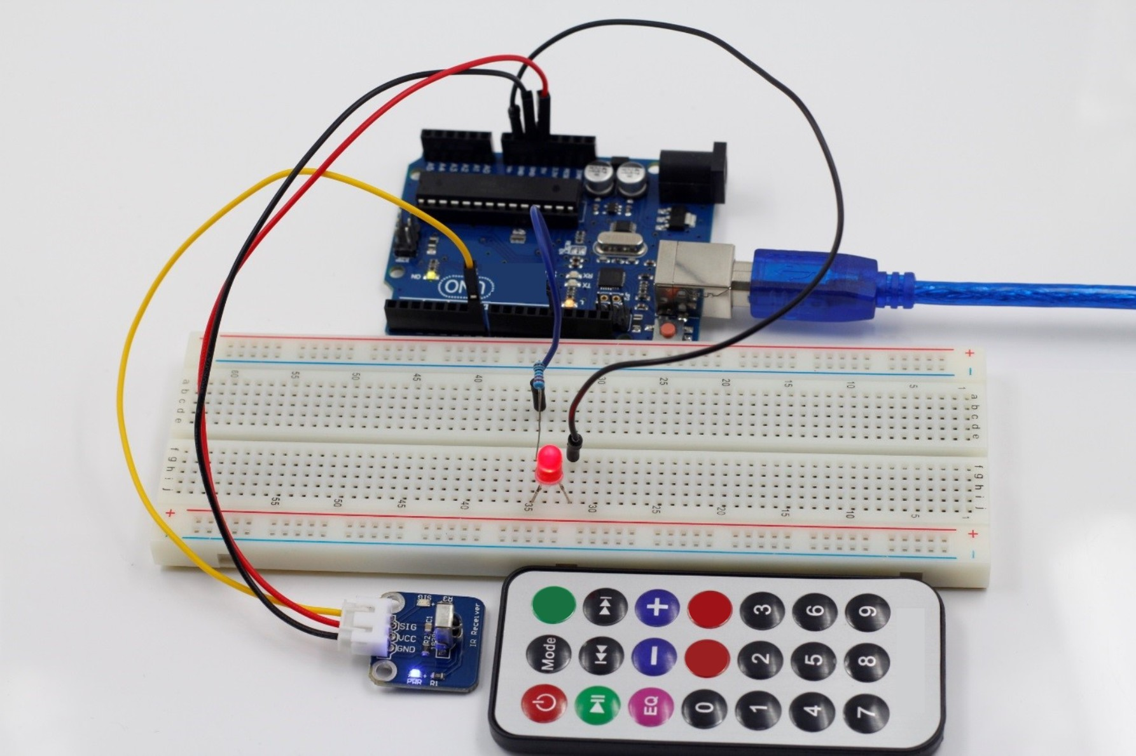

Code
/***********************************************
* name:Infrared-Receiver
* function:press the Power key of a remote control,
* and both the LED attached and that connected to pin 13 on the KUMAN Uno board will light up.
* Then press any key, and the LEDs will light out.
**********************************************/

#include <IRremote.h>
const int irReceiverPin =7; //the SIG of receiver module attach to pin7
const int ledPin = 13;//pin 13 built-in led
IRrecv irrecv(irReceiverPin); //Creates a variable of type IRrecv
decode_results results;
void setup()
{
pinMode(ledPin,OUTPUT);//set ledpin as OUTPUT
Serial.begin(9600);//initialize serial
irrecv.enableIRIn(); //enable ir receiver module
}
void loop()
{
if (irrecv.decode(&results)) //if the ir receiver module receiver data
{
Serial.print("irCode: "); //print"irCode: "
Serial.print(results.value, HEX); //print the value in hexdecimal
Serial.print(", bits: "); //print" , bits: "
Serial.println(results.bits); //print the bits
irrecv.resume(); // Receive the next value
}
delay(600); //delay 600ms
if(results.value == 0xFFA25D)//if receiver module receive 0xFFA25D
{
digitalWrite(ledPin,HIGH);//turn on the led
}
else
{
digitalWrite(ledPin,LOW);//turn off the led
}
}

